- Employee: Start Date:

(Optional) Employee contact information: ________________________________________________________
- Legal name of employer: Main office/principal place of business address:

Operating name of employer (if different): Mailing address (if different):
Phone number:

(Optional) Additional contact information: _______________________________________________________
- Is Employee exempt (from protections under Minn. Stat. ch. 177)?
☐ No, non-exempt (i.e. employee is entitled to overtime and other provisions of Minn. Stat. ch 177)
☐ Yes, employee is exempt (from ☐ overtime ☐ min. wage ☐ other provisions of Minn. Stat. ch 177)
If yes, exempt, identify legal basis for exemption:

- Rate or rates of pay: __________________
Paid by: ☐ Hour ☐ Shift ☐ Day ☐ Week ☐ Salary ☐ Piece ☐ Commission ☐ Other method ___________
(If applicable) Overtime is owed after: ____ hours per workweek Overtime rate(s) is calculated as: _______________
(If applicable to the position) – Tips are property of the employee(s). Sharing is voluntary. (Minn. Stat. ch. 177)
Allowances claimed (if any):
$ _____ per meal for meal allowance (max = 60% of 1 hour of State of MN adult minimum wage)
$ _____ per day for lodging allowance (max = 75% of 1 hour of State of MN adult minimum wage) (or fair market value)
- Leave benefits available (check all that apply): ☐ Sick and Safe Time/sick leave ☐ Other paid time off ☐ Paid vacation
How benefits are accrued (include all applicable types):
Sick and Safe Time: _______ hours accrue per ________ (OR ________ hours frontloaded per year)
Paid vacation: _________ hours/days per ____________
Other paid time off: _________ hours/days per ____________
Terms of use: ________________________________________________________________________________________
A new year for Sick and Safe Time* accrual or frontloading begins on this date: ____________
Employee may not use accrued Sick and Safe Time* before this date(s): [no later than 90 calendar days after start date]
*An employer fulfilling Sick and Safe Time (access) requirements with a vacation or other paid time off plan(s) should provide information about that plan(s).
6. Deductions that may be made from employee’s pay (and amounts if known): __________________________________
___________________________________________________________________________________________________
7. Number of days in the pay period: ______________ Regularly scheduled payday: ______________
Date employee will receive first payment of wages earned:_______________
8. (Optional) Other relevant notice or information:

I, the employee, have received a copy of this notice: ☐ Yes ☐ No
Employee Signature Date (Optional) Employer Signature Date

This document contains important information about your employment. Check the box at left to receive this information in this language.
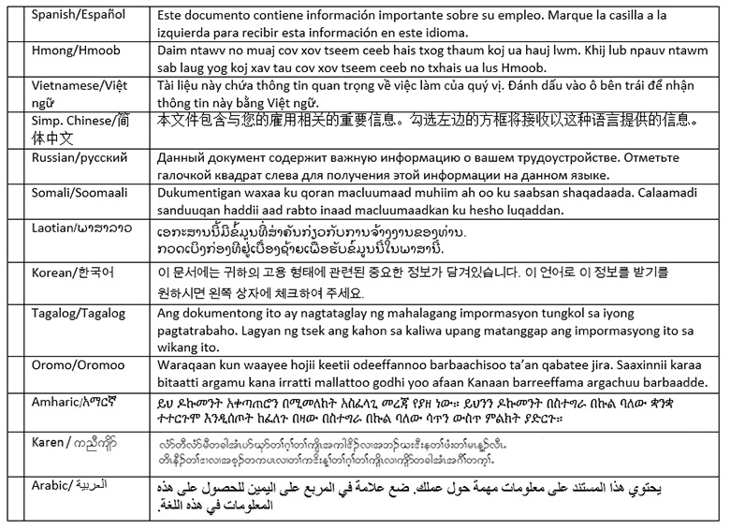

Translation providers approved by the Minnesota Department of Administration
Betmar Languages, Inc.  6260 Hwy. 65 N.E.  Minneapolis, MN 55432  763-572-9711  best@betmar.com | The Bridge World Language Center, Inc.  110 Second Street S., #308  Waite Park, MN 56387  320-259-9239  mini@bridgelanguage.com | Fox Translation Services  1152 Mae Street, #122  Hummelstown, PA 17033  866-369-1646 or 407-733-3720  dina@foxfoxcasemanagement.com
Global Translation and Interpreter  913 E. Franklin Ave., #206  Minneapolis, MN 55404  612-722-1244  sandor@globaltranslations.com | Latin American Translators Network, Inc.  1720 Peachtree Street N.W., #532  Atlanta, GA 30309  800-943-5286, ext. 8641, translations@latn.com  800-943-5286, ext. 8620, idenis@latn.com | Latitude Prime, LLC  80 S. Eighth Street, #900  Minneapolis, MN 55402  888-341-9080, ext. 501  elle@latitude.com
Lingualinx Language Solutions, Inc.  433 River Street, #6001  Troy, NY 12180  518-388-9000  abartlett@lingualinx.com | Prisma International, Inc.  1128 Harmon Place, #310  Minneapolis, MN 55403  612-349-3111  jromano@prisma.com | Swits, LTD  110 S. Third Street  Delavan, WI 53115  262-740-2590  translations@swits.us

